Name:______________________ Hr.____
Notes: Chapter 11.3 Other Patterns of Inheritance
- Incomplete Dominance
  - Incomplete Dominance results in an ______________ _______________.
  - ______________ red snapdragon (RR) is __________ with a ______________ white (R’R’), you will get all _________ with ___________ ____________(RR’)
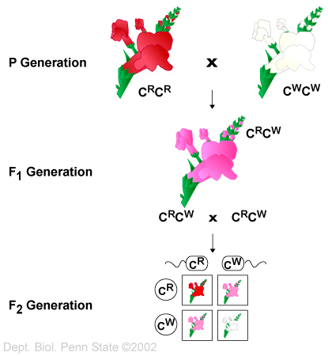

- Codominance
  - Results in the _____________ of _________ alleles.
  - ___________ _____________ (BB) ___________ with a _________ __________ (WW) will result in a:
  - ____________ ____________ (BW)!!!
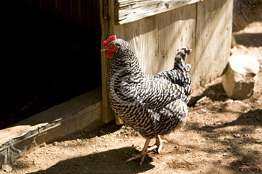
- Multiple Alleles
  - Traits _________ by ________ than ______ alleles
    - Only ________ alleles ______ in each _________ cell.
    - Sometimes up to ______ alleles for a ______ __________.
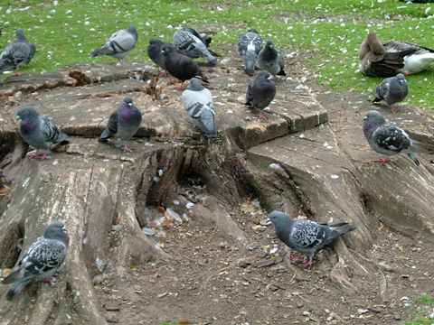

- Multiple Alleles in Blood Type
  - _________ or ________ alleles determine these traits. Each person ___________ only ________ of the alleles.
    - Blood Types: A and B antigens found on ________(Red Blood Cell)
      - _______ : I^{A}I^{A} I^{A}i^{O}
      - _______ : I^{B}I^{B} I^{B}i^{O}
      - _______ : I^{A}I^{B}
      - _______ : i^{O}i^{O}

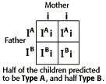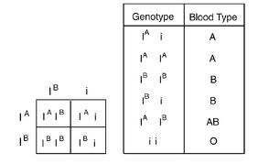

- Polygenic Inheritance (Gives a bell curve)
  - __________ ________ , _________ in humans
  - Controlled by ________ or ________ genes, each with _______ or _____ alleles.
  - Can be on the ___________ chromosome or __________ chromosomes.
  - _______ widely throughout the _______________.

- Environmental Influences
  - External
    - _____________, _____________, __________
    - Ex. ________ _________ __________, _________ ________ and ________ __________, ______________
  - Internal
    - _____________
    - Ex. ____________ ___________ _______ ________ , ___________ (baldness), feather color in peacocks. (Males vs. Females)

