Life – Reptiles and Amphibians
Based on the BBC Life Series

- The Komodo dragon is a top predator. What does this mean?

- The waterfall toad is unable to hop enough to evade predators. What adaptation does it have instead?

- Pebble toads have a similar problem. How does it escape the tarantula?

- How do caiman crocodiles take advantage of the rapid flow of the river during the wet season?

- What is the disadvantage that reptiles and amphibians have as cold-blooded animals? How do they maintain their body temperature?

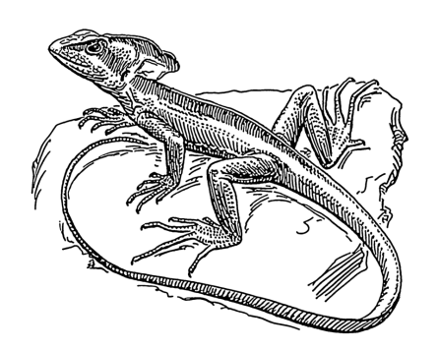
- Describe how the basilisk lizard and Brazilian pygmy gecko are able to use water as a means of escape from predators.

- The panther chameleon is described as being completely adapted for stealth. List four physical adaptations present in this reptile that make it such an effective hunter.

- Describe two ways that the namaqua chameleon uses its physical adaptations to thrive in the desert.

  - Why do the males of this species mate so aggressively?

- The male red-sided garter snakes are shown trying to warm up as quickly as possible. Why? What does the male that arose from hibernation late do to catch up?

- The horned lizard is able to successfully defend itself and its nest from two snakes: an egg-eater and a lizard eater. Name the two snakes, and explain how the lizard fended them off.

  - Egg-Eater:

  - Lizard-Eater

- Sea kraits are well-adapted for living underwater, but their eggs cannot survive there. Where do the kraits go to lay their eggs?

- After the giant bullfrogs are finished mating, one male (called a “guardian male”) is left behind. What does he do to help the survival of the tadpoles?

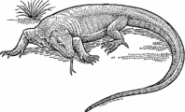
- Describe how the komodo dragons are able to successfully hunt a water buffalo, which is ten times their size.

Classification

Describe a characteristic that defines each of these orders of reptiles and amphibians.
Order Urodela
“Amphibians with Tails”

Order Gymnophonia
“Snake-like amphibians”
Class Amphibia

Order Anura
“Tailless Amphibians”

Phylum Chordata
Order Squamata
“Lizards and Snakes”

Order Testudines
“Reptiles with Shells”
Class Reptilia

Order Crocodilia
“Alligators, Crocodiles, and Caimans”

List each species of reptile or amphibian in this episode of Life. Put a check under the column for the order it belongs in, then visit www.iucnredlist.org and find its conservation status. If the animal is not listed, write “not available.”

Common Name | Urodela | Anura | Gymnophonia | Squamata | Testudines | Crocodilia | IUCN Redlist Status
Komodo Dragon
Waterfall Toad
Pebble Toad
Caiman
Basilisk Lizard
Pygmy Gecko
Panther Chameleon
Namaqua Chameleon
Red-sided Garter Snake
Horned Lizard
Sea Krait
Giant Bullfrog

