NOTES: Chapter 19 History of Life on Earth Name:_______________
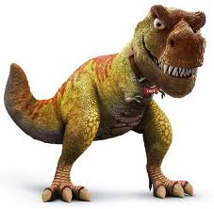
- Early ______________ of ______________
- ____________ is thought to have __________ about __________ billion years ago.
  - ________________ theorize that _________ began as a _______ _________ of rock.
- _____________ hypothesize the _________ living organism appeared in __________ about _______ to __________ billion years ago.

- A ________________ of the ______________
- No __________ have _________ to provide direct ___________ of ___________ earliest years.
- _____________ rocks on ____________ are only about _______________ billion years old.
- _______________-------- to become _______________, organisms have to be ___________ in _____________----- small _____________ of _______, _________, or __________----soon after they die.

- ________________ Time _____________
- The _________ is based on the ____________ types of ___________ ______________ that have appeared during ________________ ______________.
- ___________ __________
- ___________________ Era
- ___________________ Era
- ___________________ Era
- ___________________ Era

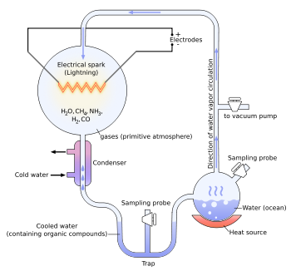

- The _________________ of Life
- The Early Ideas
- _________________________________ ----a process by which _________ was __________ to be ____________ from non-living ____________.
- __________________---- the _________ that ___________ organisms come from _________ other _____________ organisms.

- The Modern Ideas
- The ___________ of biogenesis has been accepted by ________________ for more than _________ years.
- How did __________ begin on ___________?
- _____________ hypothesis about the _________ of _____ came from analyzing different __________ and _______________, and not just ___________.
- There are ___________ competing _________ about the ____________ of ________.

