Characteristics of Arthropod Name: ____________________ Hr. ____
1. Jointed _____________________________________
2. ___________________________________ body
3. Exoskeleton (skeleton on the ________________________________)
4. _________________________________ - chewing mouthparts
5. Metamorphosis ( egg → _____________________ → adult)
Classification of Arthropods
Kingdom _______________________________; Phylum ____________________________________
Various Subphylum
1. ____________________________________ (spiders and scorpions)
2. ____________________________________ (lobsters, crabs, crayfish )
3. ____________________________________ (insects, millipedes, centipedes)
Chelicerates
Two body segments: ________________________________ and abdomen
How many legs? __________________
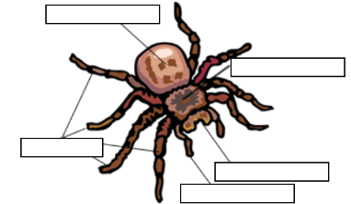
Do they have antenna? __________
Label the parts of the spider:
Spiders belong to a special group called:
___________________________________

Spider parts:
___________________________ biting mouthparts
____________________________ Appendages near mouth
___________________________ Spin webs
Crustaceans
Examples: shrimp, lobsters, crabs and ___________________________________________
Crustaceans have _________________ pairs of legs, ___________ claws, and ______________ pair of antennae
Centipedes & Millipedes
Centipedes have __________ pair of leg per segment
Millipedes have ______________ pairs of legs per segment
Which one is a poisonous predator? ______________________________
Insects
- Have 3 pairs of ________
- 1 pair of ____________________________
- 3 body segments: head, ___________________________________, and abdomen
Draw the insect and label the body segments:

Kingdom, Phylum, Class, ORDER, family, genus, species
There are many ORDERS of insects, to name a few:
1. Lepidoptera : Ex. ____________________________________________
2. Siphonaptera: Ex. ____________________________________________
3. Odonata: Ex. ____________________________________________
4. Hymenoptera: Ex. ____________________________________________
5. Diptera: Ex. ____________________________________________
6. Coleoptera: Ex. ____________________________________________
7. Isoptera: Ex. ____________________________________________

What car is named after an insect: ____________________________________

