NAME:___________________ HR.____
Flower Structure and Reproduction
Flowers are the plant's reproductive structures. Angiosperms are types of plants that bear fruits and flowers. Flowers are usually both male and female and are brightly colored to attract insects to help them carry pollen used for sexual reproduction. Not all flowers are colorful, though. These flowers usually use the wind for pollination.
Parts of the Flower
The receptacle is the part of the branch on which a flower forms. Color and label the receptacle (B) brown. Sepals are leaf like structures that surround and protect the flower before it blooms. Color and label the sepals (C) green. Petals are the colorful part of the flower that attracts insects and even other small animals, such as mice, birds, and bats. Color and label the petals (D) a bright color of your choice. All flowering plants have flowers, but some are not brightly colored. The petals of these flowers are reduced or absent, and the plant relies on the wind or water for pollination.
The flower has both male and female reproductive parts. The female reproductive structures are called carpels. In most flowers, the carpels are fused together to form a pistil. Color and label the pistil (P) pink(or light red). The pistil has three parts, which can be seen, in the box labeled "pistil.” The stigma at the top is often sticky and is where the pollen attaches. Color and label the stigma (J) purple. The style is the long tube that attaches the stigma to the ovary. Color and label the style (K) red. Sperm from the pollen will travel down this tube to the ovules. The ovules, or eggs, are stored in the ovary until they are fertilized. Color and label the ovary (L) pink(or light red). Plants can only fertilize eggs of the same species. Special chemicals prevent sperm from fertilizing the eggs of flowers that are not the same kind. Color and label the ovules (O) black.
The male reproductive structures are called the stamens. Color and label the stamens (H) blue. Each stamen consists of an anther (A), which produces pollen, and a filament (F), which supports the anther. In the box labeled "stamen" Color and label the anther dark blue, and the filament light blue. The anther produces pollen. Insects or other animals carry pollen to the pistil of another flower where it may fertilize the eggs.
The other flowers in the picture follow the same plan, although they come in many different colors and styles. Color and label each of the flowers according to the colors above (blue for stamen, pink for pistil, bright colors for the petals. etc.). Note that in some of the flowers, not all the structures are visible.
Plant Reproduction
Sexual reproduction in plants occurs when the pollen from an anther is transferred to the stigma. Plants can fertilize themselves. This is called self-fertilization. Self-fertilization occurs when the pollen from an anther fertilizes the eggs on the same flower. Cross-fertilization occurs when the pollen is transferred to the stigma of an entirely different plant.
When the ovules are fertilized, they will develop into seeds. The petals of the flower fall off leaving only the ovary behind, which will develop into a fruit. There are many different kinds of fruits, including apples, oranges, and peaches. A fruit is any structure that encloses and protects a seed, so fruits are also "helicopters,” acorns, and bean pods. When you eat a fruit, you are actually eating the ovary of the flower.

Questions:
1. What is an anther?
2. The flower attaches to what part of the plant?
3. Why are flowers brightly colored?
4. Name two mammals that might pollinate a plant.
5. If the petals of a flower are reduced or absent, how is the plant pollinated?
6. The female reproductive structures are called the:
8. Name the three parts of the pistil:
9. Where are the ovules stored?
10. Name the two parts of the stamen:
11. Describe sexual reproduction in plants.
12. The ovary develops into what structure?
13. Define fruit.
14. What is an angiosperm?

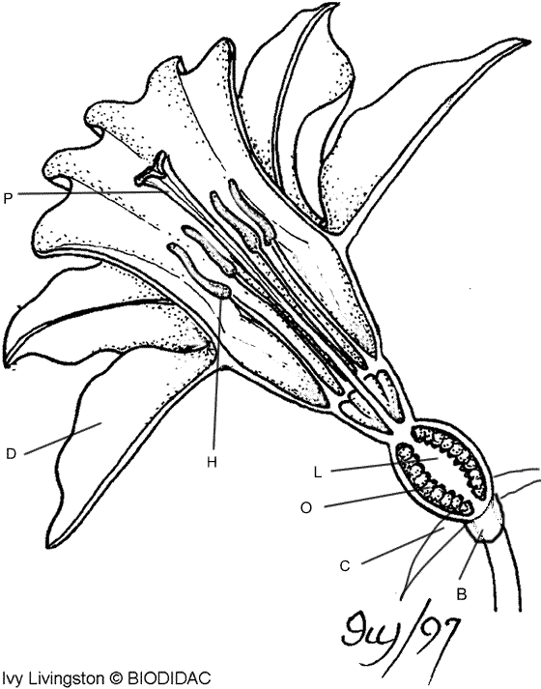 | 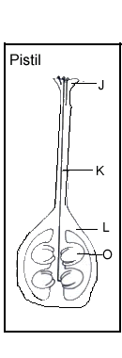  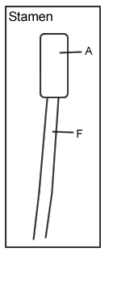

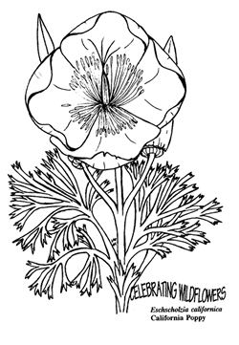 | 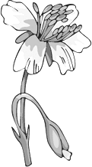 | 