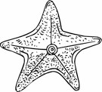
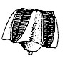
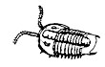

Activity Two:
The Classic Fossil Lab - Simple Format

Materials: Lab Handout, One Baggy for each group with the following items: trilobite, brachiopod, pelecypod, horn coral, blastoid, shark’s tooth, gastropod, cephalopod, sea urchin or starfish.

NOTE: If your fossils don’t match mine, then do some substitutions. You can change the pictures on the front of the lab. You may have to add to the key, but most basic phylums are present in this key.

DIRECTIONS:
- Hand out labsheets to each student and baggy of fossils to each group.
- Have the students carefully remove the fossils from the baggy and place on the table. Give them time to pass them around the group. It is nice to have each student handle each fossil and get familiar with each fossil’s characteristics.
- Then have the students place the fossils on one student’s labsheets, matching fossils to illustrations on the labsheet/
- Walk around and check to be sure they are right. Adjust if necessary.
- Once they have an okay from you, they need to use the Fossil Key to identify each fossil. Make sure they use pencil to write in case they are incorrect.
- Walk around and okay the identifications.
- Once a group’s ids are okayed, they can start working on the Summary Questions.

NOTE: Be sure to count the fossils in each baggy when you collect them to be sure something hasn’t “disappeared!”

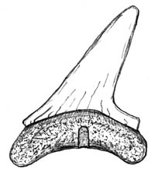
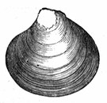
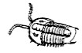
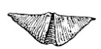
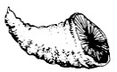
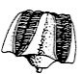
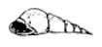
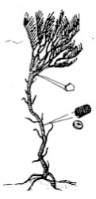
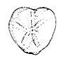
Fossil Identification Lab

DIRECTIONS: Remove your fossils from their container and place on top of the matching fossil on this labsheet. Have the teacher okay your placement. Then use your key to identify the fossils. Write the common name each the line.

1. ________________________ 2. ________________________ 3. ________________________

4. ________________________ 5. ________________________ 6. ________________________

8. ________________________ 9. ________________________

7. ________________________

Fossil Lab Questions
1. What are fossils? _______________________________________________________________

________________________________________________________________________________ HINT: Check your textbook for the answer!
- Are the fossils in your packet plants or animals? land or marine (sea)?
HINT: Check the Fossil Identification Key before you answer this question!

- What is the main difference between a plant and animal?________________________

_________________________________________________________________________________ HINT: What can plants do for themselves that animals can't do?
4. How many fossils are echinoderms? ___________________________________________

What is a characteristic of this phylum? ________________________________________

Go to this website: https://en.wikipedia.org/wiki/List_of_U.S._state_fossils
Does your state have a State Fossil? yes or no

State fossil name(s)_____________________________
____________________________________________________________
Are they plants or animals or both?

- The Trilobites were marine animals in what era?

What are some modern examples of arthropods?
Sketch (State Fossils)

- How do Brachiopods attach to the sea floor?

- How does horn coral appear to differ from hexagonaria?

- Why are teeth the most common fossil of a shark?

- Why is it so important to learn about fossils of ancient animals?

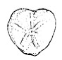
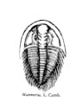
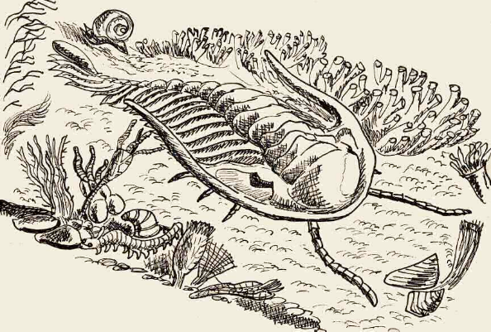
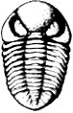
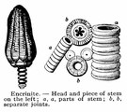
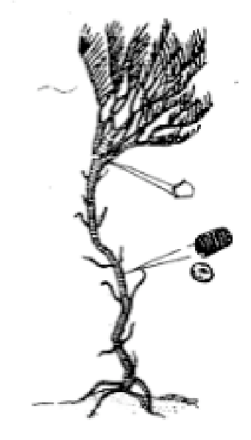
FOSSIL IDENTIFICATION KEY
Images obtained from the Internet and altered for clarity.
1. Phyllite: ECHINODERMATA
Geologic Time Period: Paleozoic - Cenozoic
Echinoderms are marine animals usually having a five-fold (pentagonal)
symmetry. Some are attached to the bottom by stems, whereas others are free- moving. Most live by filtering food out of the water, but at least one croup (the starfish) is carnivorous. Some members of the Phyllite are extinct, but there are many living examples. Crinoid fossils (a variety of "Sea Lily."
A. CRINOIDS
Sea Lilies
Pal. to Cenozoic
B. Sea Urchins Echinoids Pal. to Cen.
C. Starfish Stelleroids Pal. to Cen.
D. Blastoids
Pal. to Cen.

2. Phyllite: ARTHROPODA
Geologic Time Period: Paleozoic
Arthropods make up a wide range of organisms. They include modern crabs,
lobsters, crayfish, insects, and spiders. Besides these, they also include an extinct class called the TRILOBITES. Trilobites were marine animals that swam, floated, crawled, and burrowed their way through the Paleozoic Era. Some of the various types are pictured below:

Trilobite

Trilobite
Trilobite
Trilobite
Trilobite

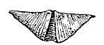
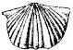
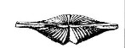
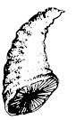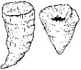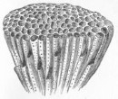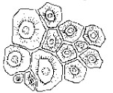
4. Phylum: BRACHIOPODA
Geologic Time Period: Paleozoic to Cenozoic
Brachiopods were more common during the Paleozoic Era than they are today.
Some grow attached to the rocky sea floor by an "anchor line" called a pedicle. Others "sit" on softer substrates where they are supported by spines.
Brachiopod
Brachiopod
Brachiopod
Brachiopod
3. Phylum: COELENTERATA
Geologic Time Period: Precambrian - Cenozoic
Of all the coelenterates, corals are by far the most conspicuous as fossils. Corals
are important reef-builders and reefs commonly form important petroleum reserves.
A. HORN CORAL
B. HEXAGONARIA
C. FAVOSITES

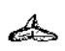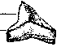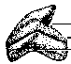
5. Phylum: CORDATE
Geologic Time Period: Cenozoic
This great phylum of the animal kingdom includes the most highly developed
animals that have ever inhabited the Earth: fishes, amphibians, reptiles, birds, and mammals, including man. All animals in the Cordate Phylum have backbones. They are also called Vertebrates.

Class of Cordates: Chondrichthyes (Cartilage Fishes) the sharks, rays, and skates. Of the fishes that controlled the ancient seas, sharks have survived in relatively large numbers to the present day.
Shark's Teeth

