INSECT COLLECTION ASSIGNMENT
The insect collection will consist of 10 properly pinned insects.

Materials needed
Euthanizing - The best way to kill the insects is to put them in a bag or container in the freezer for at least a day. Pin within a couple of days before they start drying out. Another option is to make a small glass jar "loaded" with ethyl acetate (often an ingredient in fingernail polish remover) absorbed on a cotton ball.
Box or piece of Styrofoam or both. – for displaying your collection.
Pins - pins are required.

Pinning and Labeling:
- The pin should be placed in the correct location for that insect (see Fig. 1) which is spread out to see its wings and legs in a natural position and have 10 mm of space between the head of the pin and the insect.
- Insects that are too small to be pinned (less than 1/4" long) may be mounted with glue on a small paper point (see Fig. 2). The point should go to the left, with the head of the insect pointing straight ahead. The point should not extend beyond the midpoint of the insect's body.
Do not collect insects unless you are prepared to pin them soon after they are dead. Insects dry out quickly, so pin them while they are still moist. It is possible to rehydrate dried insects to some extent by placing them on a piece of paper in a hydration chamber (closed plastic container containing several moist sponges). Most insects are pinned through the thorax a little to the right of center, but there are exceptions. Beetles should be pinned through the right wing. Generally, insert the pin through the insect until the insect is approximately 1.0 cm or 3/8" from the head of the pin. Stick the insect and pin into a piece of thick styrofoam, or something similar, until the insect rests near the styrofoam. With the aid of pins or tweezers move the legs and antennae to a natural position. The insect will dry just the way you arrange it, so do this quickly and carefully. Leave the insect in this position for a week (or more for larger insects) to allow for adequate drying. Large winged insects (moths, butterflies) should be pinned on a piece of foam with a groove cut into it to accommodate its body; fix the insect in place with enough pins and paper strips to keep them flat (see Fig 3). A video example of how to pin large winged insects as well as construct a hydration chamber can be found at http://www.youtube.com/watch?v=62pOS0mM-ww.
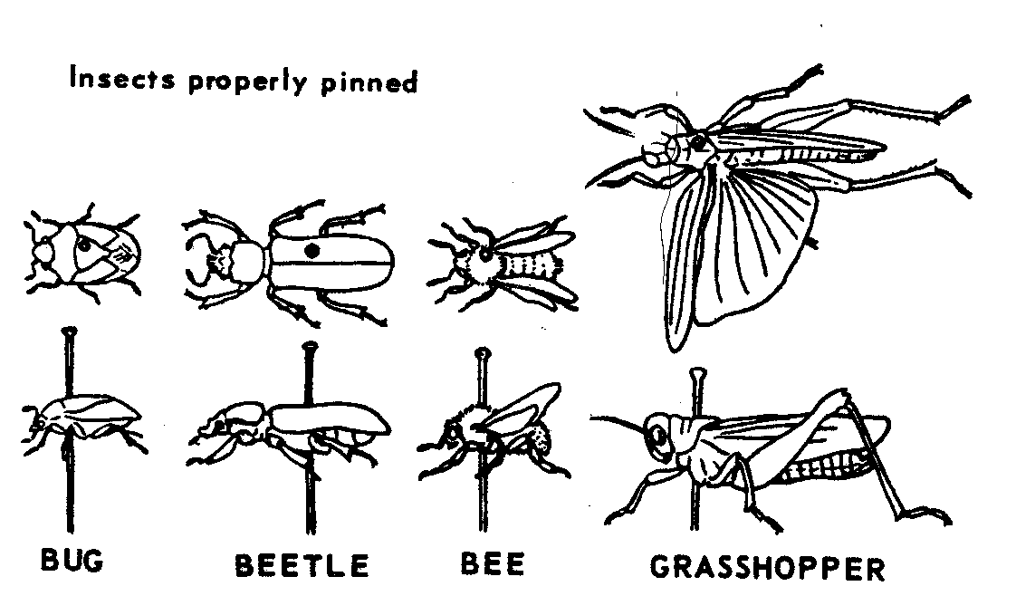Fig. 1 Fig. 2 Fig. 3
Bug Beetle Bee Grasshopper

Insects properly pinned

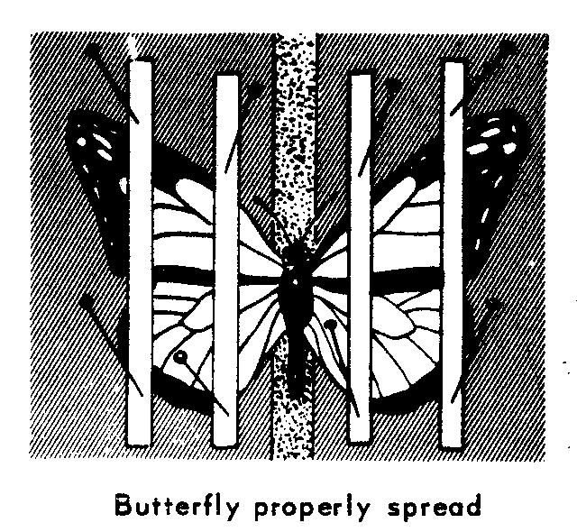

Use Order labels to organize your collection. These should be placed on the bottom of the box, with the members of each order pinned in rows going from the back of the box to the front. Use a name label and collection info label for each insect. The pin must be placed through the center on the labels at a uniform height under the pinned specimens with the labels in line with the body of the insect.

Grading:
Fig. 4
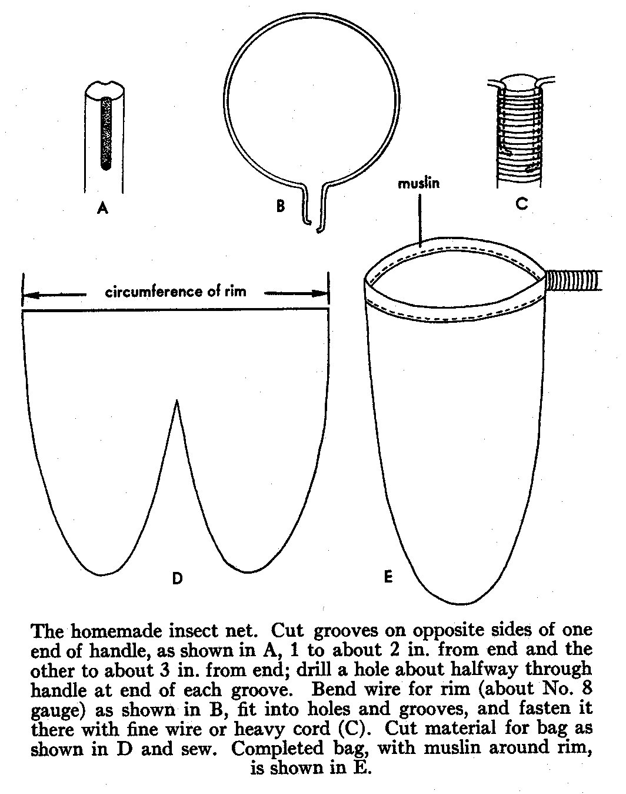We are looking for quality not just quantity. The insect collection is a major part of your grade for the first semester. The criteria used for grading include: completeness, proper identification, proper pinning/labeling technique, effort, organization and overall neatness. Major deductions will be taken for insects that are not completely dry.
Allow adequate time for the insects to dry. Be aware that it takes longer for some insects like mantids to dry. No collections will be accepted after the due date, so send it with someone or turn it in early if you will be absent on the due date.
Grade:
10 Insects pinned and Identified by common name and order name.
14 points each for a total of
140 points.
Additional insects up to 5 will be equal to up to 25 points extra credit.

Due October 30, 2015

Insect Collection FAQCan I use an insect that my little brother caught for me?
Yes. Remember that you must put the collector’s name on the label after you pin it. It is just like citing a source on an English paper; failure to do so is equivalent to plagiarism. Also, if your collection has a significant, noticeable percentage of insects that were not collected by you, then your grade will reflect that. (Just like an English paper that was entirely quotations without any of your own ideas.)
Can I use an insect that I bought or that was collected somewhere else?
No. All of the insects must be collected and pinned by you (or collected by your family/friends on your behalf). You may not purchase any insects or use those you collected from some far off land on last summer’s vacation to Peru. When in doubt, ask the teacher ahead of time… don’t risk being blamed for unethical academic behavior.
Where is the best place to collect insects?
I recommend visiting the web site maintained by the Bohart Museum of Entomology (UC Davis) at http://bohart.ucdavis.edu/resources_howtocollect.aspx
Can I use insects from a previous year’s collection?
No. This is cheating. No insects may be used from previous students.
What do I do with an insect that is too small to pin?
Glue it onto the tip of a small paper triangle then pin the triangle.
What kind of glue do I use?
Any glue that dries clear; Elmer’s glue or clear nail polish work well.
Which way do the labels face?
They must be aligned with the body of the insect so that the words can be read on the left side of the insect’s body.
Do I have to spread the wings of small moths and butterflies?
Anything the size of a skipper or bigger (approx. the size of a dime) must have the wings spread properly (90-degree angle on the back edge of the front wings). You may keep the wings in a folded back position for smaller moths.
What kinds of insects should go into a vial with alcohol?
Generally, soft-bodied insects such as silverfish, aphids, termites, Jerusalem crickets, larvae of any kind, caterpillars, etc. You may also put problematic insects such as crane flies and mosquitoes into vials.
What kind of alcohol do I use in vials?
Rubbing (isopropyl) alcohol works best.
How do I pin a praying mantis?
Put the pin through the thorax at an angle with the head higher and the abdomen resting on the styrofoam. The front legs should be in the “praying position” under its thorax. The back two pairs of legs are treated like the other insects. Don’t spread a wing. There will be little room under the mantis for labels, so they will be closer together than other insects.
Insect Collection Labels
Order Labels to be placed in the bottom of your box to group your insects:
Dermaptera
Neuroptera

Protura

Phasmatodea

Blattodea

Location and Name Labels:
Mantodea

Hymenoptera

Mallophaga
Hemiptera
Thysanoptera
Anaplura
Psocoptera
Zoraptera
Embioptera
Siphonaptera

Diptera

Lepidoptera

Trichoptera

Strepsiptera

Mecoptera

Coleoptera

Isoptera
Orthoptera
Odonata
Ephemeroptera
Collembola
Thysanura
Plecotera

Prepared, pinned specimens are to be identified by a top and bottom tag which must include:
Top tag Bottom tag
-location of capture -Order
-date of capture -Common name
-name of collector
example:
Hymenoptera
Yellow Jacket
Yolo Co., Davis, CA
Sept 8, 2008
John Doe
As previously mentioned the labels below are available online as a Word document for you to fill in as you collect. Copy and paste to make additional tags.
(Bottom Tag)
(Top Tag)
(Bottom Tag)
(Top Tag)
(Bottom Tag)
(Top Tag)

Hymenoptera
Yellow Jacket
Yolo Co., Davis, CA
Sept 8, 2008
John Doe
Hymenoptera
Yellow Jacket
Yolo Co., Davis, CA
Sept 8, 2008
John Doe
Hymenoptera
Yellow Jacket
Yolo Co., Davis, CA
Sept 8, 2008
John Doe

