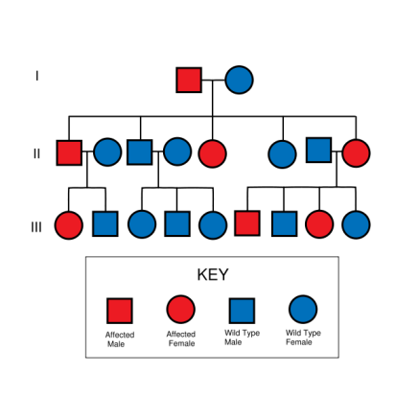
Name:
Part One

- Go to the following link: http://www.saburchill.com/IBbiology/chapters03/006.html

  - Why do scientists use pedigree charts?

  - Draw the symbol that represents a male.

  - Draw the symbol that represents a female.

  - What does a line in between two individuals represent?

  - How is an individual that is affected by the trait shown?

  - Describe how a pedigree chart differentiates between parents and offspring.

  - What is a generation? How many generations are depicted in the pedigree at the bottom of the page?

  - Look at the top pedigree. How many children does that couple have? What are the sexes of the children?

  - Look at the bottom pedigree. How many children does the original couple have? Are any of these children affected individuals? Explain.

  - In the bottom pedigree, in the fourth generation, list the sex of each child from oldest to youngest.

Click on the next website: http://www.saburchill.com/IBbiology/chapters03/007.html

  - What are monozygous twins? How are monozygous twins represented on a pedigree chart?

  - What are dizygous twins? How are they represented?

  - What is an X-linked trait?

  - What is meant by an affected individual? How is an affected person represented on a pedigree chart?

Part Two

A. Draw a pedigree chart for the following family. Charlie and Renee are grandparents. They have 3 children, Jessica, Crystal, and Gina. Jessica is married to Gale and they have a daughter named Rue. Crystal is married to John and they have 3 children, Alice, Mark, and Ian. Gina is divorced and has 2 daughters, Kate and Rose. Please refer back to the two links if you are not sure about how to depict this information.

- Answer the following questions using the next website: http://www.ygyh.org/hemo/whatisit.htm

and go to “How is it inherited?”

  - How does a boy get hemophilia?

  - How does a girl become a carrier?

  - If a woman is a carrier and the male does not have hemophilia, draw a Punnett Square and indicate the possible outcome (phenotype and percentages). Use the letter H and h.

Genotype ratio:

Phenotype ratio:
Part Three

Now use the information that you learned about Hemophilia to complete your pedigree chart from Part two of this lesson. Indicate that Charlie, Gina, Ian, and John have hemophilia by shading in the symbols that represent them in the Pedigree Chart.

- Explain in a sentence or two how hemophilia is inherited. Describe which parent gave Ian the defective allele(gene) for hemophilia and explain how you know.

Part Four
Read further about sex-linked genetic disorders: http://anthro.palomar.edu/biobasis/bio_4.htm
- What sex chromosomes are found in males? Females?

- Explain why females might carry a recessive X-linked trait, but not express it, where as men always express X-linked recessive traits.

- How many human X linked traits are known?
- Give 3 examples of non-female anatomical traits that are located on the X chromosome.

- Draw and briefly explain using Punnett squares the following genetic crosses: (Hint: Look at the examples on this link.)
  - A woman with normal vision but who carries the colorblind gene marries a man with normal vision.

  - A colorblind man marries a woman homozygous for normal vision.

- What sex linked trait ran through the royal families of Europe?

- How many genes are located on the Y chromosome?

- How many genes located on the Y chromosome are involved in sperm production vs. cellular activities?

- How many couples in America are infertile?

- What is a significant cause of infertility in men?

