Name: _______________________

Notes Reptiles and Snakes:
- Kingdom ___________________
----Phylum __________________
--------Subphylum ___________________
----------------Class _____________________

- Characteristics of Reptiles
      - ___________________________
      - ___________________________
      - ___________________________
      - ___________________________
      - ___________________________
      - ___________________________
      - ___________________________
- The Amniotic Egg
Contains a ______________ and __________________ supply for the developing _____________ and can be laid on land.

Must be _________________ internally, has a ___________.
Fill in missing labels:
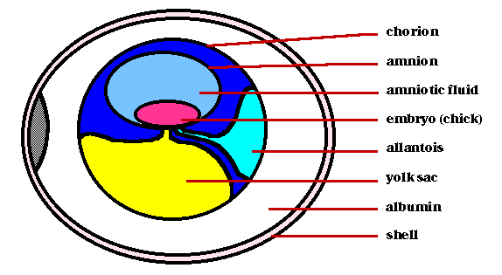
- Parts of the Amniote Egg
  - Amnion = _________________________________
  - Yolk = ____________________________________
  - Allantois = ________________________________
  - Chorion = __________________________________
  - Albumen = __________________________________
- Types of Reptiles
_____ Main Groups (_____________)

Crocodilia = ___________________________________
Testudines = ___________________________________
Sphenodonta = + _______________________________
Squamata = ____________________________________

_______________________ usually live on the land, ______________ in the water.

Snapping turtles can be very _____________________.
The top of the turtles shell is the _____________, the bottom is the __________________________.
______________________ are found mainly in North and South ____________ and only live in ________________.
Alligators only show their _________ teeth when their ___________ is closed, and their snouts are _______________ (u-shaped) compared to Crocodiles. Crocodiles can live in __________ or ___________water, most are found in Africa, India, and ______________.
Crocos have a _____________ snout and show both _______ of _______ when their mouths are _____________.
The __________ Crocodile takes care of its _____________, a unique trait among reptiles.
The ___________ is a crocodilian with a ________, _________ snout.
- Lizards and Snakes
Belong to the Order ________________
Komodo Dragon--- have ______________ in their mouths that make their bites ___________ to prey. Sometimes a dragon will bite a large animal and wait for it to ________ from an ______________.

The ________ Monster is a ________________ lizard, found in the southwestern United States.

The _________ Lizard is also venomous. It is called __________ lizard because its _____________ look like __________.

The ___________ Lizard has an unusual ______________ mechanism. It will squirt ___________ from its ______ to scare away predators.

- Snakes
Snakes can be ___________________ or ________________ to kill prey. All snake ___________ their prey ___________.

Snakes have _______ Types of ____________:
- __________________ ---- affect the ___________, causing _______________ and internal _______________.
- ___________________ ---- affect the ______________ system, causing _____________, the ___________ to stop working or ___________ difficulties.
Fill in the missing labels:

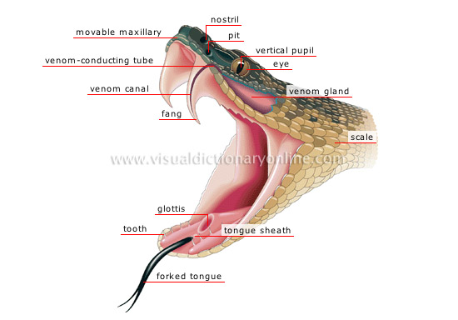
Red next to ____________, friend of _______________. Red next to __________________, kill a ________________.

