NOTES: What is an Animal? Name:________________________ Hr.____
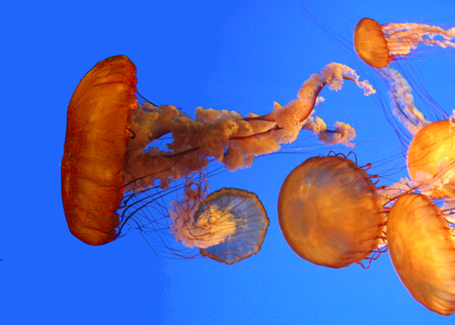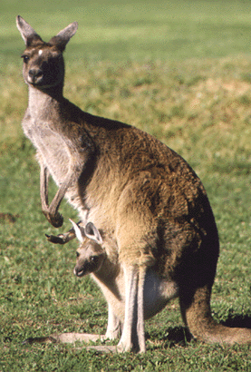
- Characteristics of _________________
  - All ________________________
  - Eukaryotes (cells with ____________ & _______________)
  - Ingestive ___________________ (take in _________ and internally digest it)
  - Store __________ reserves as ________________.
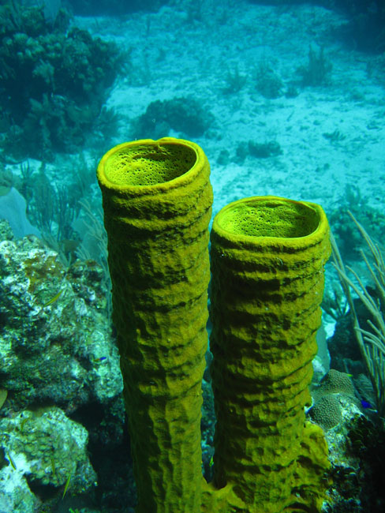
- Support Systems
  - Have some type of _________________ support
  - _____________________ inside and made of ______________ &/or _______
  - _____________________ found in arthropods
    - Cover the ____________ of the _________
    - ___________ size
    - Must be ___________ making animal vulnerable to _____________
  - _____________ and echinoderms (starfish) have fluid-filled _________ cavities giving them ___________
  - Called _________________ skeletons

- Movement
  - Animals such as _____________ may be ____________(attached and non-moving)
  - Animals that _________ very little are said to be ____________(clam)
  - Animals that can move are ___________
  - Have ______________ tissue to provide energy for _______________

- Reproduction in Animals
  - _____ animals are capable of _____________ ________________
  - Some animals like ___________ and _____________ are hermaphrodites producing both ___________ and ____________
  - Hermaphrodites may exchange sperm and do __________ fertilize their own eggs
- Levels of Organization
  - ______________ are the ________ animals that have just the ___________ level
  - _____ other animals show these levels
    - _______, __________, ________, and __________
    - Cells may _______________(take on different shapes and ___________)
Levels of Organization: ________, Molecule or compound, _____________, Cell, _________, _________, Organ System, ________________.
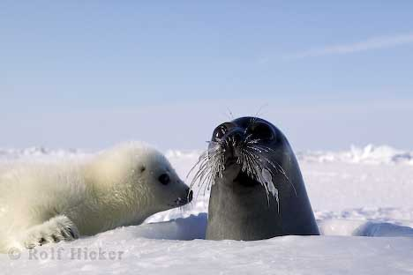
- Characteristics of Invertebrates
  - _____________ animals
  - Contain the ____________ number of ____________ species
  - Most are __________ (found in water)
  - Do _________ have a ____________
  - Includes sponges, cnidarians, flatworms, annelids, mollusks, arthropods, and echinoderms
- Characteristics of Vertebrates
  - Most ___________ animals
  - Most have a _____________ made up of individual bones called ___________
  - From ____________ to most _____________, the phylum includes: _______, amphibians, _____________, birds, and ____________
  - Vertebrates have ___________________ (internal)
  - Some vertebrates have skeletons of ____________(sharks, rays, and skates)
  - Other vertebrates have skeletons of ____________ and _____________(reptiles, birds, & mammals)
- Body Areas----Surfaces
  - ___________-----back or upper surface
  - ___________-----belly or lower surface
  - ___________-----head or front end
  - ___________----- tail or hind end opposite the head

- Body Symmetry
  - _______________ is the __________________ of body ___________ around a ___________ plane or _______.
  - ________________ occurs when the body __________ be ___________ into similar sections (___________)
  - Radial ________________ occurs when __________ parts are _________________ around a _____________ point like ____________ on a ________________ ( ______________________)
  - Most ______________ with ___________ symmetry are ________________ (attached) or ____________________ (move very little)
  - Bilateral ______________ occurs when _____________ can be _______________ into ______________ halves along a __________ plane
  - Organisms will have __________ and ____________ sides that are ______________ images of each other
  - More ____________ type of _________________
  - Animals with _________________ symmetry are ________________ motile.
  - ____________________ have an __________________ and _________________ ends.
  - Show _____________________ (concentration of _______________ organs on the ___________ or anterior end)