Chapter 20 Virus NOTES: Name:_______________
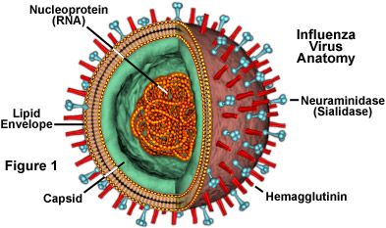
- Viruses----tiny, ______________ particles. They do ______ grow or carry out _____________. They _________ reproduce inside a _______ cell.

- Strucure-----a virus consists of an ________ core of _____ or _____(never both) surrounded by _____ or _____ protein ________.

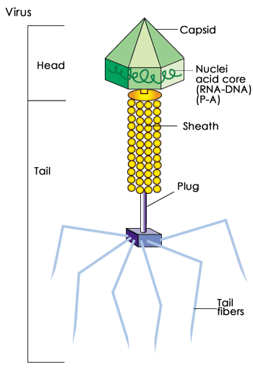
- Viruses have a _________ of __________, determined by the _________ coats. Viruses are _________ specific, with some being ____________ specific.

- Viral Reproductive Cycles
  - Lytic Cycle----- Virus _________ the host cell’s _____, uses cell’s ____________ and ____________ make new viruses.
  - Lysogenic Cycle---the viral nucleic acid (_______ or _______) becomes a ______ of the _____________ of the _______ cell, lays _____________, and __________ with it.
  - Provirus------virus is in the cell’s ____________ and ________ ___________.
  - Retroviruses-----_______ viruses with the most ________ _______________ cycles.
- Origin of Virues----- ______________---- maybe some _______ or _________ escaped from a ______ cell and ______________ a way to ___________ as _______________.

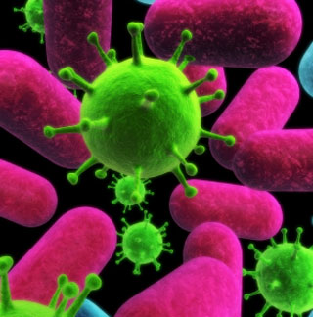

Video Questions: (circle your answer.)
- You can get rid of a viral infection using antibiotics. True or False

- Viruses can reproduce on their own through the process of mitosis. True or False

- What instrument is often used to see a virus, due to the size of most viruses?
____________________ Microscope

- The cell can recognize when the virus injects its genetic material into the cell. True or False

- The cell can survive without its cell membrane. True or False

- Which cycle allows viruses to remain dormant (hidden) for long periods of time? Lytic Cycle or Lysogenic Cycle

