Chapter 7 Cell Structure & Function Name: __________________
Section 7.1 “Life is Cellular”

- ________________
- ________________ living _________
- ________ are ___________________

- ___________________ of ______________
- Robert ________________ (mid-1600s)
- __________________ sliver of _____________
- Saw “row of __________ __________ “
- _____________ the term ______

- ________ _____________
- (1839) Theodor _______________ & Matthias _______________
“_____ living ________ are _________ of __________”

- (50 yrs. Later) Rudolf ____________
“ _______ cells __________ from __________”

- ____________________ of Cell ______________
- All _________ things are ________ of _________

- _______________ living ______ of ___________ and function of all ______________ is the _______

- All _________ arise from ________________ cells ( this _______________ discarded the _____ of __________________ generation)

Cell Sizes
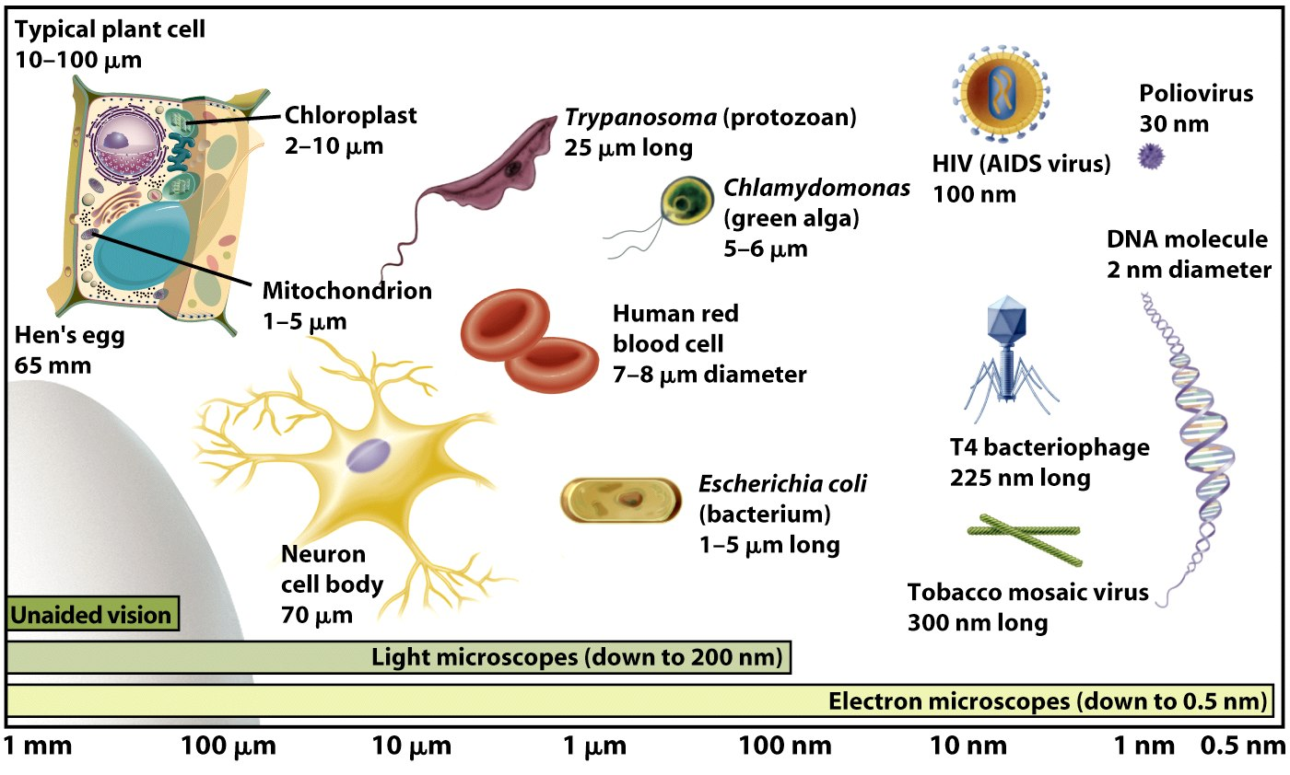
- _________ Have Large ________________ Area-to-_____________ Ratio

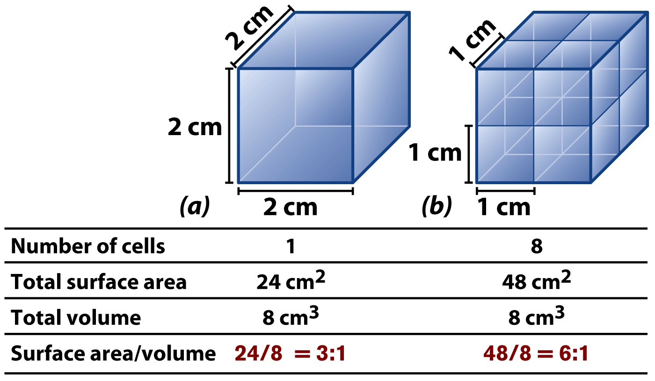
- _______________________ of All _______
- A _________________________ ___________________
- Protoplasm(___________________) – cell ___________ in ___________ fluid
- ________________ --- structures for _______ ________________
- _______________ ____________ with ______
- Cell Types
- ________________________
- ________________________
Prokaryotic Cells
- No ___________________ bound ________________
- ______________ = region of DNA _________________________
- ________________ not bound by __________________________
- ______ type of ________________
Eukaryotic Cells
- ___________________ bound by ________________________
- Include __________, ____________, ___________ and ____________ cells
- _________________ many organelles (miniature organs inside the cell)
- Types of ___________________________
- _____________________ Light _______________________ --- use a _______ of ___________ to _____________ objects in steps. Can _________ up to ___________________ times.
- ____________________ Microscopes ---- _________________ in the 1930s and 1940s
- This ______________________________ uses a __________ of _________________ to _____________ structures up to ______________________ times their ____________ size.
- _____________________ must be examined in a ________________.

