Chapter 8 Photosynthesis Name: _____________ Hr. ___

6 _____ + 6 ______ + Light Energy ---------- ___________ + 6 _____

--- Takes ________ in the ____________ of ____________ cells.

---- _____________ are ______ because they _________ the _______ light of the ________ ____________ and ________ all the other _________.

What is ATP?

The ________ ____________ used by _____ cells is __ __ __ .

A______________ T______________ ----- _____________ Base, ___________ Sugar and ____ Phosphates.

_____________ molecule containing _______- __________ Phosphate _______.

Chemical Structure of ATP (LABEL)
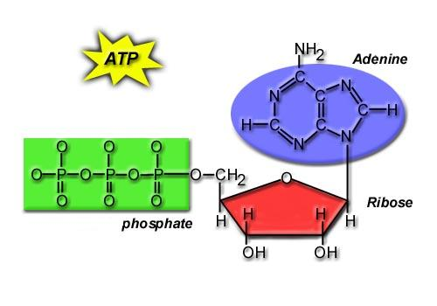

What does ATP Do for YOU?
It __________ YOU with ____________!

