ECOLOGY NOTES Part 2
NAME: _____________________
DATE: ________________
PERIOD: _______________

Trophic Levels
- Each ______ in a food ________is known as a _________ level.

- Trophic levels ___________ a feeding ______ in the _________ of _________ and matter in an ecosystem.

____________- the _________ of __________ matter comprising a group of organisms in a habitat.

- As you move ___ a food chain, both available _________ & _________ ____________.

- _________ is transferred upwards but is _____________ with each transfer.

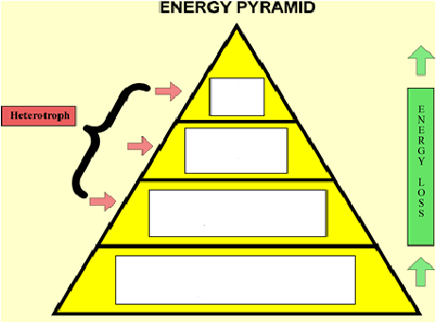

________ chain- __________ model that shows how matter and __________ move through an ecosystem

Draw a sample food chain that you might see in Kansas: include a producer, a primary consumer, a secondary consumer, and a tertiary consumer

_____________ _____________ ______________ _____________

Food ______- shows ____ possible feeding ______________ in a community at each _________ level

- Represents a ____________ of interconnected food _________

Food chain- just ___ path of energy

Food web- ____ possible energy paths

Nutrient Cycles

Cycling maintains _______________ (balance) in the environment.
- ___ cycles to investigate:
1. ________ cycle

2. _________ cycle

3. _____________ cycle

________ cycle- evaporation, _______________, condensation, ________________

_________ cycle- _________________ and ______________ cycle carbon and ___________ through the environment.

___________ cycle- __________________ nitrogen (N₂) makes up nearly ___ %-___ % of air.

Organisms ____ _____ use it in that form.

_____________ and ___________ convert nitrogen into ___________ forms.

Only in certain ____________ and industrial ______________ can _____ nitrogen.

Nitrogen______________ - __________atmospheric nitrogen (N₂) into ____________(NH₄⁺) which can be _______ to make organic compounds like__________ ________.

Nitrogen-fixing_____________: Some live in a ______________ relationship with plants of the ____________family (e.g., soybeans, clover,____________).

- Some ____________-fixing bacteria live _______ in the_______.

- Nitrogen-fixing ________________are essential to maintaining the fertility of semi-__________ environments like ______ paddies.

__________ in food chains-

While energy ____________ as it moves up the food chain, __________ ___________ in potency.

- This is called _________________ ________________
Ex: ______ & Bald ___________

