Enzyme Foldable Instructions
Steps:
- Use this foldable pattern to create a four-tab, shutter fold as shown below.
Tab 2
Tab 1
Tab 3
Tab 4

- On the FRONT of each tab, draw and color the 4 general steps of enzyme activity using the sketch below. Color the enzyme RED, substrate A – YELLOW, substrate B – BLUE, and the product GREEN.
SUBSTRATES
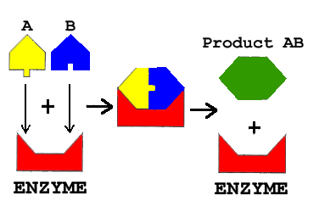
2
ENZYME-SUBSTRATE COMPLEX
4
3
1
- On the BACK of each tab, list the following from your notes or search online for answers:
  - Tab 1 – Meaning of enzyme, substrate, & active site
  - Tab 2 – Explanation of induced fit
  - Tab 3 – Factors that affect enzyme action (3 to 4 factors)
  - Tab 4 – Examples of biological enzymes (3 to 4 examples)

- On the CENTER FOLD(the wall behind the four tabs), write ENZYME CHARACTERISTICS and then bullet each of these answers:
  - Enzymes are HIGHLY SPECIFIC!
  - Enzymes are REUSABLE!
  - Enzymes are BIOLOGICAL CATALYSTS!
  - Enzyme are FRAGILE – ABLE TO BE DENATURED EASILY!
!!!The most important feature of an enzyme is its SHAPE!!!
  - Enzymes work in ONE DIRECTION OR THE OTHER, BUT NOT BOTH!
- Make sure you put your name and hour on it someplace before turning it in.

