Notes: Mammals Name: ___________________
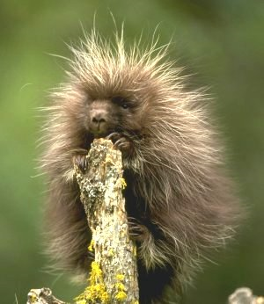
Kingdom: ________________
---Phylum: ________________
-----Subphylum:______________
-------------Class ________________

Characteristics:
- ________________________________________________________
- ________________________________________________________
- ________________________________________________________
- ________________________________________________________
- ________________________________________________________
- ________________________________________________________

Evolution of Mammals:
Mammals did not come to dominate until the _____________ ___________, after the ________________ became ________________.

Early Mammals were probably ____________ and _______________.

How do mammals stay ____________?:
____________ insulates most mammals.
Some ____________ mammals have a layer of ______________ _______(blubber).

What is the _______________?:
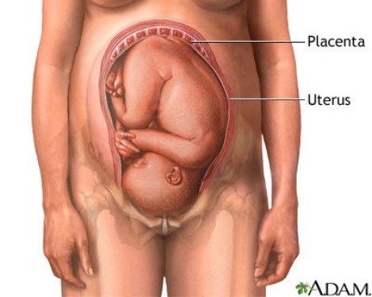
Attached to the _________ of the _________, it provides the _________ with ___________________________.

What are _______________ __________?:
Only found in _______________, produce ____________ to _________ young.

How the _________________ ___________________?:
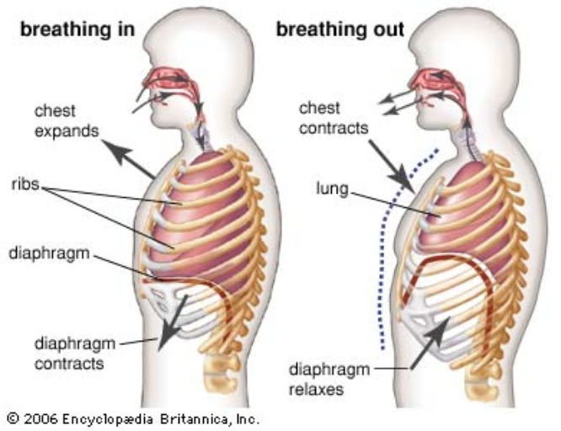

Specialized ____________:
- ________________----- biting
- ________________-----stabbing, holding
- ________________-----crushing, grinding

Different types of ______________ have different types of __________-----depending on their __________.
________________ have large __________.
________________ have large ________ ______________.
The _______________ of ______________ are very large and _________, used for tearing ________________.
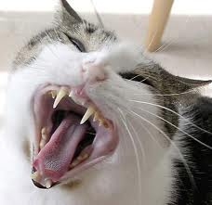
Digestion:
________________ have diverse ________.
__________________ often have an _________ stomach chamber called a ____________ to help them ________ ___________.
This chamber holds ____________ that can ____________ __________ material.
Circulation:
Mammals have a ___-- chambered ________ and __________ loop circulation.

Movement:
Mammals are a diverse group. Some…. 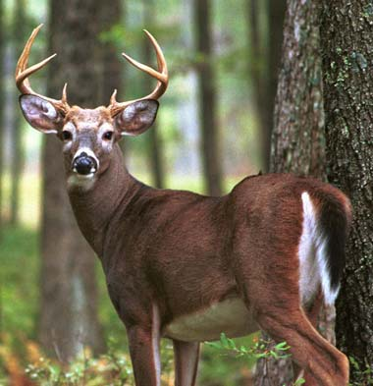
- _____________
- _____________
- _____________
- _____________
- _____________
___________ are adapted to a ______________ job.

Reproduction:
Most mammals give _____________ to ____________ young.
There are _________ groups that are exceptions…….
- _______________(lay eggs)
- _______________(develop young in a __________)

Order Monotremata:
- _________ ______________ mammals found only in ________________.
- Have ___________ __________________ (cloaca & egg laying)
- Have ____________ features (hair, mammary gland)
Examples: __________ __________ Platypus and the _____________ (also called a ____________ Anteater).

Order Marsupiala:
- Mammals _________ their young in an __________ state, babies develop in a _____________.
- Majority are found in ____________, ___________ are found on other continents.

Placental Mammals:
- ______________ Mammals have a ____________ __________ (length of time in ____________).
- ______________ ______________ have been kept and bred by people --- _________, _______, _________, __________... etc.

