Name: ___________________ Hr. _____
NOTES: 11.4 Meiosis
- Genes and Chromosomes
- _______--- a _______________ of DNA that __________ the ____________________ of a _________________
- Organisms have ______ of _________________ of _______
- A ________________ or more _______ on each ______________
- _____________________ occur in _______--- ____ from ______ and _____ from dad.
- __________________----- _______________

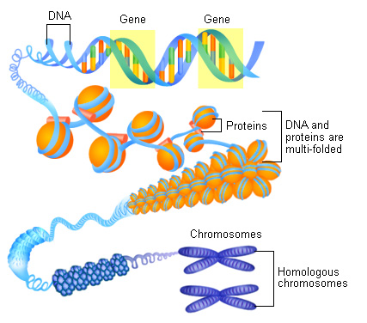
- Genes, Chromosomes, and Numbers
- A _______ with ______ of each kind of _______________:
----- _________ Cell
----- _________
----- ___n
- A ______ with _____ of each kind of ________________:
----- __________ or _____ cell
----- __________
----- n
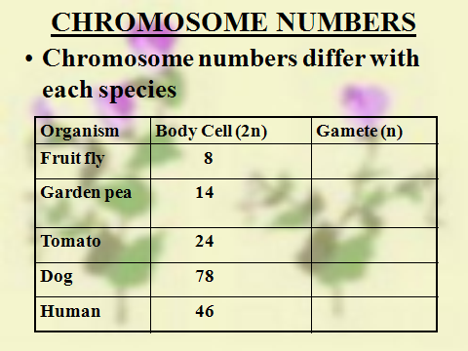

- Meiosis
What is _________?
--- Cell _________ that ___________ gametes containing ______ the ________ of ___________________(haploid cells)
--- ________ gametes are called ________
--- female __________ are called _______
--- When a _________ fertilizes an ______, the resulting _____ is a _________(sexual reproduction)
Why ________?
---IF we get ______ from mom and _____ from dad, there has to be a
_____________ within _____ that ________ those “____” cells!
---- Chromosome _______________ cannot _________ each ___________.
Phases of Meiosis
- Interphase
--- ______________ activity, ___________ chromosomes
- Prophase I
---- ___________ forms (______ homologous ___________ )
---- ______________ over ____________ occurs
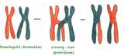
- Metaphase I --- _______________ line up in the ____________
- Anaphase I --- _______________ chromosomes _________ and move to opposite ends.
- Telephase I --- ________ cells are formed.
- Prophase II--- _________ become ___________.
- Metaphase II--- chromatids ______ up in the ________.
- Anaphase II---paired chromatids _________ and move to opposite _____.
- Telophase II
--- _____ haploid cells have been formed, having _______ of the ________ number (n) of the organism’s ______ cells.

