Notes Chapter 10 Cell Growth and Division: Name: ______________
- Cell Size Limitations--- ___________________________________________________________
- Diffusion---- ______ & _________ over ________ distances, it is __________ & ______________ as the ____________ becomes ______________.
- DNA Content--- most ______ contain only ____ nucleus. Bigger _________ require more _______ to run things.
- Surface area-to-volume ratio ---- as cell’s size ______________, its ______________ increases much __________ than its ___________ ______.

- The Role of Chromosomes:
- _______________ ---- dark-staining ___________ that contain _____________ material.
- ________________---- are strands of ________ wrapped around __________ molecules.
- _____---- is actively involved in making _____ and in _____________ itself.
LABEL this Diagram:
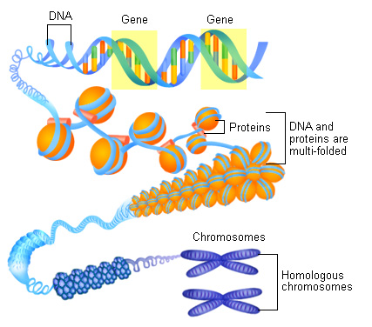
- The Cell Cycle---- ___________ is a _________ that __________ nuclear material ___________ between ____ _____________ cells.
- ___________ --- normal cell ___________ take place. ____________/_________ are copied.
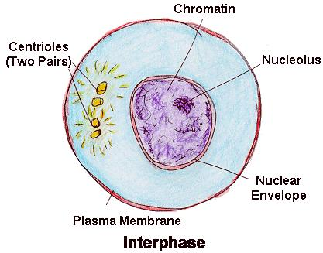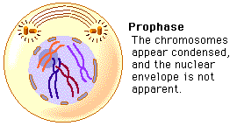
- ____________---- Chromatin becomes ________________. Nuclear ___________ & _____________ disappear. ___________ ____________ form.

- ______________---____________ attach to spindle fibers and _____________ ____ in the ___________.
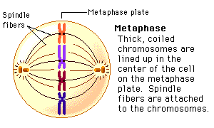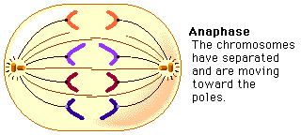
- _____________---- Sister ____________ (paired chromosomes) separate and _________ to ___________ _________ of the cell.

- _____________---- ________________ uncoil; spindle fibers _____________ _________; the _______________ & _____________ membrane reappears. _____________ membrane & ______________ divides(_______________ ).
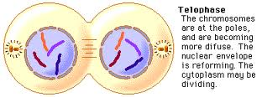

- Mitosis is a ____________ that ________________ genetic ________________. Resulting in a ________________ of ___ new __________ with the __________ number of chromosomes as the ________________ cell.

