NOTES CHAPTER 13.3---MUTATIONS Name:______________

- ________________---- any ___________ in the _________ sequence.
- ___________________ can be caused by ___________ in ;
- ___________________
- ___________________
- ______ _______________
- ____________ _____________-----i.e. _______________ exposure.
- ___________________ _____________
- If the ________________ occurs in a _________ or _________ cell:
- May _____________ a __________ _________.
- Results in a _______________ that _____________ work ________________.
- _________________ or __________________ problems.
- __________________ may not ________________.

- Body Cells
- If the ________________ occurs in a ____________ cell:
- Is __________ passed onto ________________.
- ________________ a _____________.
- May _____________ the ________________ of a _______.
- ________________ is _______________ by a ________________.
Two ___________ of _____________________
- _______________________________------ a _____________ in a __________ base pair in ___________.
- Changes _______ __________ __________ which can ____________ the ____________ structure of a ____________.

- _______________________________ ----mutation in which a __________ base is ____________ or ____________ from _________.
- Causes _____________ ___________ ____________ from that point on to be _____________.

Chromosomal Alterations
- ________________________________---- caused when ________ of _______________ break off or _________ incorrectly. Effects the ________ ______________ not just a ________.

- _______________ --- when ________ of a _______________ is left out, a ____________ occurs.

- _______________---when ________ of a chromatid ____________ off and ___________ to its ____________ chromatid. ____________ in a duplication of ___________.

- ____________---- when _______ of a _________________ breaks off and ______________ backwards.

- ___________________----- when part of one ________________ breaks off and is _________ to a ______________ chromosome.

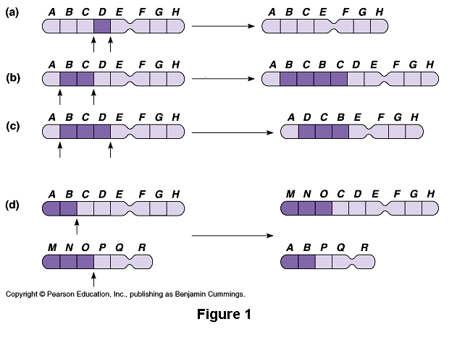
- Causes of Mutations
- _________________________-----some _________________ seem to just ________________.

- __________________________________: Mutagen---any __________ that can ____________ a change in __________.
- ________________----X-rays, UV light, etc.
- ________________-----dioxins, asbestos, benzene, & formaldehyde
- ___________________________

