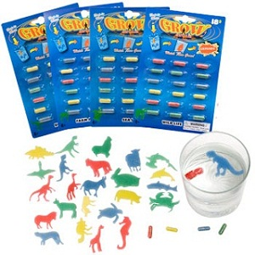
Sponge Capsules

Name: _______________________ Hr. ___

Materials:
Magic Capsules
water (warm and cold temperature)
beakers/cups
stirrers (plastic spoons work)
Purpose
- develop a hypothesis
- test a hypothesis
- collect data
- analyze data
- compose a lab report
Background: In the lab you will be given two gelatin capsules that contains sponge animals which are common toys usually labeled as "magic capsules". The animals will grow when placed in water. Consider the following questions about sponge animals.
Does the temperature of the water affect the rate of growth?
The Experiment
Lab Report (on google doc or a separate piece of paper)
I. Introduction: Question and Hypothesis
2. Procedure: List Materials and Method (step by step) List Independent Variable, Dependent Variable and Control.
3. Data: Carry out experiment and collect data. (Charts and Tables are nice)
4. Conclusion: Draw your conclusions from data, talk about hypothesis and positives and negatives are experiment.
Choose one question and develop a hypothesis. Remember to state your hypothesis in a complete sentence and make sure that it is testable.
Describe how you will test this hypothesis.
Gather the needed materials and test your hypothesis.
Construct a data table that shows your experiment and the data gathered. Make sure that the table is labeled correctly and is neat.
Write your conclusions. Your conclusions should answer the experimental question. Use your data to support your answer. Suggest a reason why the sponge animals behaved the way they did. Talk about what went well, wrong, and things you would change next time.

*Turn in your lab report by Thursday September 1 or Friday September 2*

