Protons, Neutrons, and Electrons Practice Worksheet

Calculating the number of each particle in an atom:

# Protons = Atomic Number
# Electrons = Protons
# Neutrons = Atomic Mass – Atomic Number OR Big # - Small #

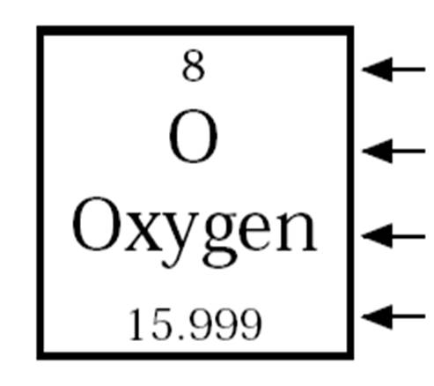

Use the periodic table to find the numbers of protons, neutrons, and electrons for atoms of the following elements.

Name of Element | Element Symbol | Mass Number | Atomic  Number | Protons | Neutrons | Electrons
Boron | B | 11 | 5 | 5 | 6 | 5
Oxygen |  | 16 | 8
 | Y | 89 |  |  |  | 39
Copper |  |  | 29 |  | 35
 | Tc | 98 |  | 43
 | Pb | 207
Thallium |  | 204 | 81
 | H |  |  |  | 0
Carbon |  | 12
 | N |  |  | 7
 | Ba |  |  |  |  | 56
Calcium
 | Si |  |  |  |  | 14
Argon |  |  | 18
 | Mg |  |  | 12 |  | 12

Name of Element | Element Symbol | Mass Number | Atomic  Number | Protons | Neutrons | Electrons
Lithium | Li |  |  |  |  | 3
Sodium |  | 23 | 11
Gallium |  |  |  | 31 | 39
 | K | 39 |  |  |  | 19
Phosphorus |  |  | 15 |  | 16
 | S | 32 |  | 16
 | Cl | 35
Ytterbium |  |  |  |  | 103 | 70
 | Ac | 227 |  | 89
 | Mo |  |  |  | 54
Mercury |  | 201 | 80
 | Fm |  | 100 |  | 157
 | No | 259
 | Ne |  |  |  | 10
Helium |  | 4
 | F |  |  | 9
 | Fe |  |  |  |  | 26
 | Al |  |  | 13 |  | 13

