Zoology Bird Notes: Name: ___________________
________________________ is the study of birds.
Characteristics of Birds:
- ____________________________________________________
- ____________________________________________________
- ____________________________________________________
- ____________________________________________________
- ____________________________________________________
- ____________________________________________________
- ____________________________________________________
- ____________________________________________________
Classification:
Kingdom ____________________________
---Phylum____________________________
--------Subphylum______________________
---------------Class _______________________

Aviation = __________________

Types of Feathers:
Down Feathers---- ____________________________________
Contour Feathers---__________________________________________
Flight feathers--- ____________________________________________
- Feathers are covered in ______ to keep them ________ _________-“like water off a duck’s back” – this oil is secreted from a ___________
____________.
- ___________________ is a behavior that replaces the oil on feathers, and repairs broken links on the _____________.

Evolution of Birds (from reptiles)
- Archaeopteryx—“_________________”
- ______________ --- Had teeth in beak, bony tail, claws on wings.
- ______________ --- Had feathers, and fused collarbone(wishbone)

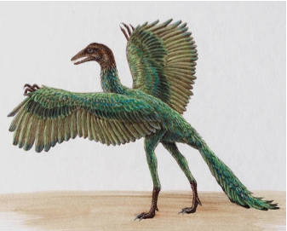

Adaptations for Flight:
- _____________________________________________________
- _____________________________________________________
- _____________________________________________________
- _____________________________________________________

Feeding:---- shape of the __________ related to food(diet).
Examples: __________ beaks used for tearing meat. _______ _______ beaks for spearing fish.

Digestive System:
- Birds lack ____________
- _________ stores and moistens food.
- ___________ grinds the food.
Label this bird’s digestive system:
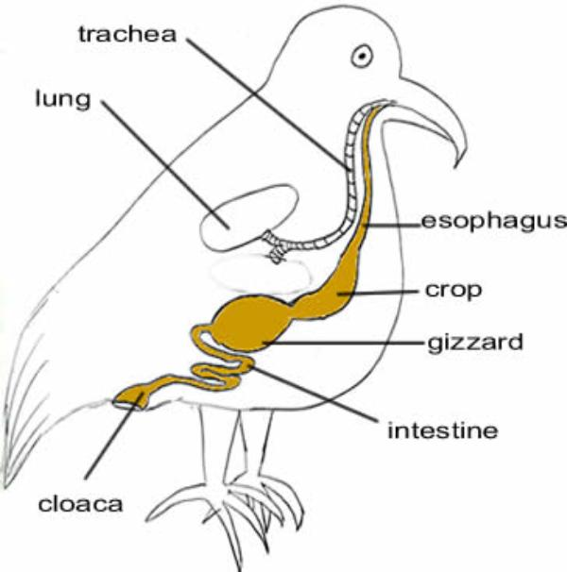
Others Systems:
Respiration:
- ______________----_______________---______________________----_______________
- A one way flow of oxygen.
Circulation:
- ___ chambered heart (___________---loop system)
Excretion:
- _____________ (uric acid) & Cloaca

Nervous System:
- Well developed sense organs
- A ____________ brain
- __________________ = thinking, decision making
- __________________ = coordinated movement
- Medulla Oblongata = __________ ______________ _______________
- Optic lobes = ____________
- Olfactory lobes = ____________ and _____________

Movement:
- Flightless (___________, _____________.....etc.)
- Forelimbs modified for flight = __________
- Collarbones are fused making a strong base for flight muscles --- fused bone is the ______________.
- _____ _________ make the bones light in weight
- Strong chest muscle attach to a ________ of the _____________ (breastbone)

Reproduction:
- ________________ Fertilization + ________________ Egg
- Incubation
- “__________ ____________”
